_{NIKE BRSLA XS DUFF}
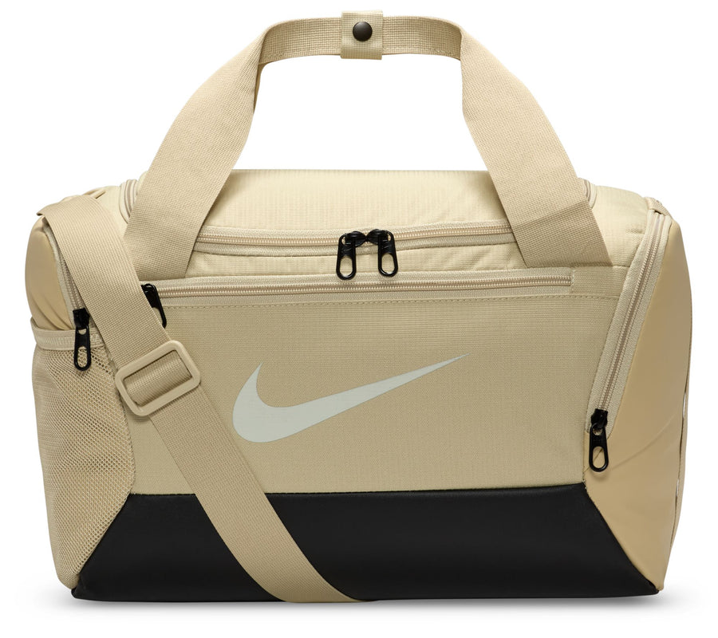
PRICE: Approximately Rs. 7,499

_{Introduction:}
The Nike Brasilia XS Duffel Bag is a compact yet highly functional carry solution designed for everyday training and short trips. Despite its small size, this duffel offers smart storage and durable construction, making it ideal for gym sessions, sports practice, or quick outings. Its lightweight design allows easy carrying, while the sturdy fabric ensures it can handle daily wear and tear. With a clean, sporty look and iconic Nike branding, the Brasilia XS Duffel combines practicality and style, making it a reliable companion for an active lifestyle.
Product Overview:
The Nike Brasilia XS Duffel Bag is designed to keep your essentials organized and protected. It features a spacious main compartment for clothing and gear, along with additional pockets for smaller items. About the Brand:
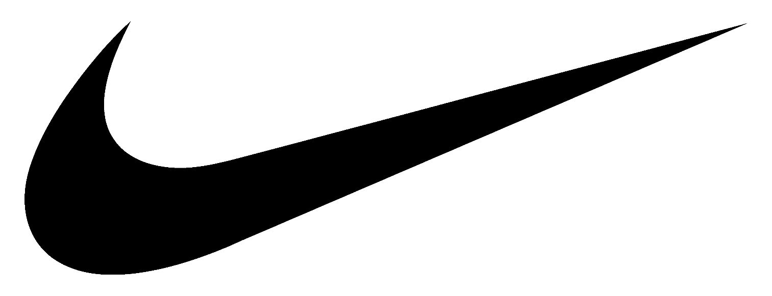
Nike is a world-leading sportswear brand known for innovation, performance, and iconic design. With decades of experience in athletic footwear and apparel, Nike continues to set global standards in comfort, durability, and style for athletes and lifestyle users alike.

Key Features:
- Designed for training and skill development
- Compact size with efficient storage space
- Durable fabric for long-term use
- Spacious main compartment
- Zip pockets for small essentials
- Iconic Nike logo branding

Design & Build Quality:
The Nike Brasilia XS Duffel features a clean, structured design with reinforced stitching for added strength. Its compact shape makes it easy to carry while maintaining enough space for daily essentials. The sturdy base helps the bag retain its shape even when fully packed.
Storage & Capacity:
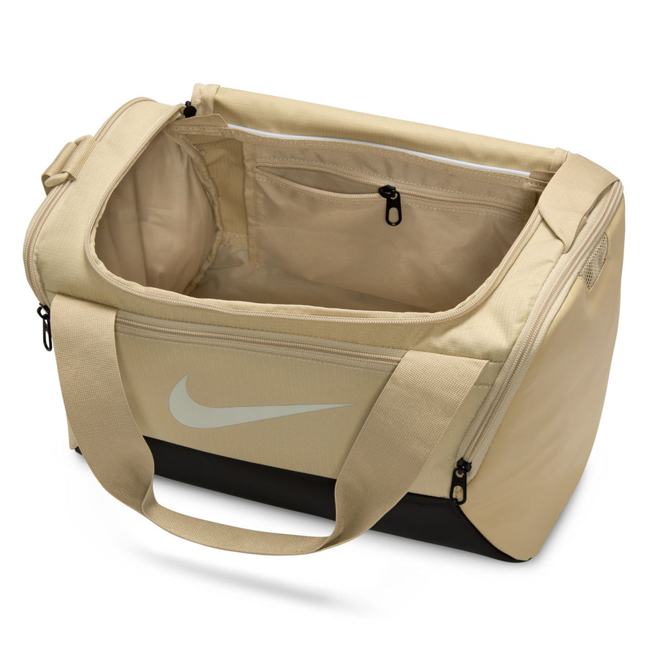
The duffel offers a well-sized main compartment suitable for gym clothes, shoes, or sports gear, along with additional zippered pockets for accessories such as keys, wallets, or phones. Its compact size makes it ideal for short trips and daily workouts.

Material & Durability:
The duffel offers a well-sized main compartment suitable for gym clothes, shoes, or sports gear, along with additional zippered pockets for accessories such as keys, wallets, or phones. Its compact size makes it ideal for short trips and daily workouts.
Ideal For:
- Gym workouts and training sessions
- Sports practice or short trips
- Carrying daily essentials
- Users who prefer compact sports bags
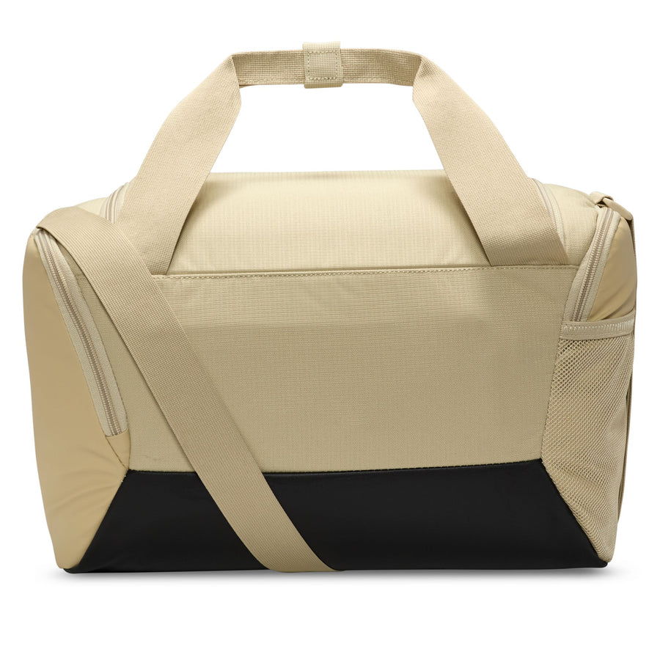

Care Instructions:
- Wipe clean with a damp cloth
- Do not machine wash or bleach
- Air dry away from direct sunlight
- Store in a dry place when not in use
Product Specifications:
- Brand: Nike
- Model: Brasilia XS Duffel
- Product Type: Sports Duffel Bag
- Material: Polyester
- Compartments: Main zip compartment + accessory pockets
- Strap Type: Adjustable shoulder strap
- Closure: Zipper
- Capacity: XS (Compact size)

Product Summary:
The Nike Brasilia XS Duffel Bag is a practical and stylish choice for everyday training and short trips. Compact yet durable, it offers smart storage, easy portability, and the trusted quality of Nike, making it an excellent option for active users.

